Regression

* A statically measure that attempt to determine that strength of the relationship between, **one depend variable and serious of other independent variable.**

Dependent variable – Y (Output)

And serious of other Independent variable - X (Input)

The Aim is to predict forecast value of dependent variable(Y) from the value of dependent variables(X1, X2, X3 ….)

Example –

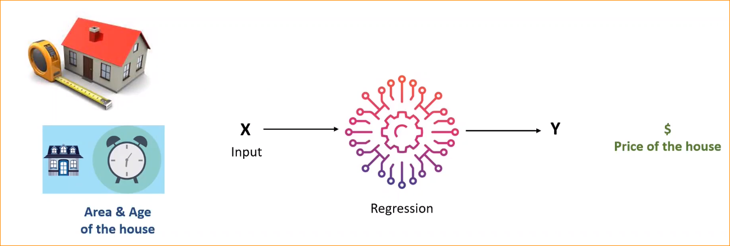

Input may be one or more.

Here predict value is price of the house.

Given detail of the house – Ex Area and Age

Price of the house is continuous variable. And price is the dependent variable. Because price dependent variable both Area and age.

Hare independent variables Are Area and Age of house.

**Variable** –

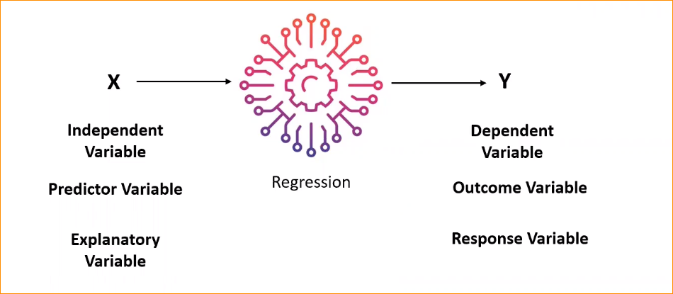

Input – predictor variable (Use to predict the ouput Y)

Output- Outcome Variable

Explanatory variable – this use to explain the Y

Response Variable – Output, Y refers as a response variable

All input output are regression types.

Types of Relationship

1. Leaner Relationship

X is change with particular amount, in the fix ration Y will be increasing or decreasing.

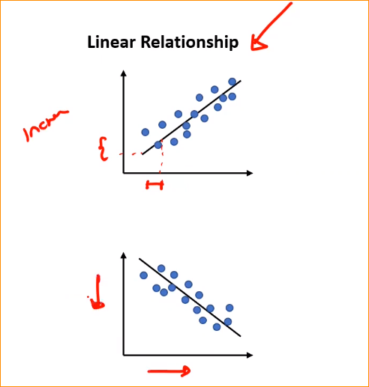

In this example, 1 X is gone And Y also increasing

Example 2 X increasing and Y decreasing.

Example - y=2x+3 represents a linear relationship where the slope is 2, and the y-intercept is 3.

**Increment or decrement in the same amount.**

* Strong Relationship

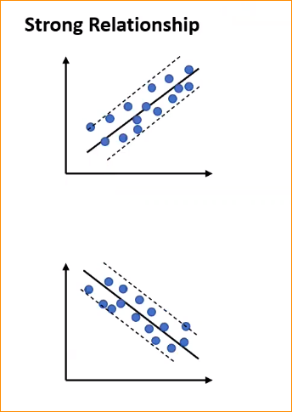

* In a strong relationship, there is a high degree of association or correlation between the two variables.
* The changes in one variable are closely linked to changes in the other variable, and the correlation coefficient is close to +1 or -1.
* A strong relationship suggests a more reliable basis for predicting the values of one variable based on the values of the other.

.

* 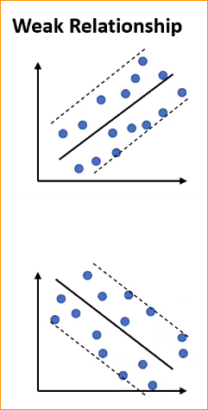 In a weak relationship, there is a low degree of association or correlation between the two variables.
* The changes in one variable are not closely tied to changes in the other variable, and the correlation coefficient is close to zero.
* A weak relationship does not provide a reliable basis for predicting the values of one variable based on the values of the other.

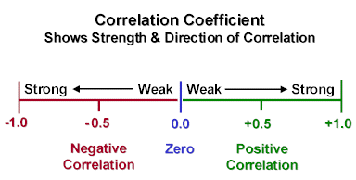Correlation coefficients –

Correlation coefficients range from -1 to +1, where:

* +1 indicates a perfect positive linear relationship.
* -1 indicates a perfect negative linear relationship.
* 0 indicates no linear relationship

1. Nonlinear Relationship

In a non-linear relationship, the relationship between the two variables cannot be represented by a straight line.

The relationship may take various forms, such as curves, exponential growth, decay, or other complex shapes.

Non-linear relationships do not follow a constant rate of change, and the slope varies at different points.

Example: y = x^2 represents a non-linear relationship where the dependent variable is the square of the independent variable.

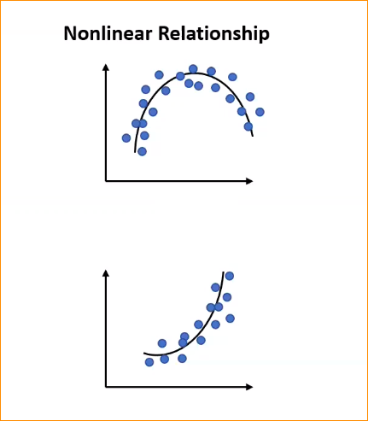

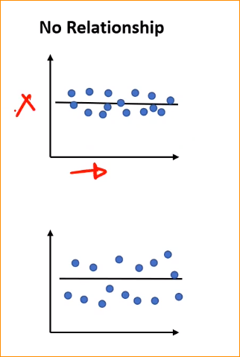

1. No Relationship

That mean when X change but Y is not change.

**Linear Relationship –**

Simple Linear Relationship (Linear Regression with one variable)

* Only **one independent** variable X
* Relationship between X and Y is assumed to be linear.

Only have Single input and Only have Output X🡪Y(Y is Continuous) so we assumed F will be linear.

In here relationship is straight line or

This we called **Simple Linear Regression**

Other one is **Univariate Linear Regression**

**Linear Model -**

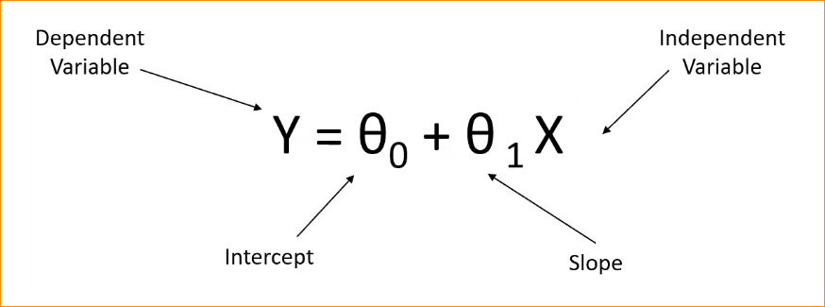

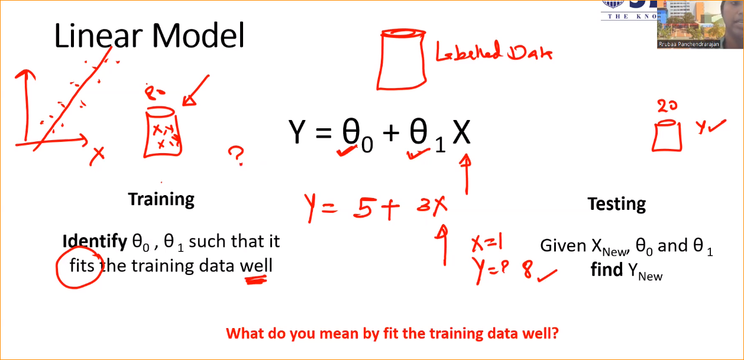

In here Process is same- Get data setb devided two, Testing and Traning (20% and 80%)

In Traning we have X and Y, in here We will learn that **Theta 0** and **Theta 2**

This is reffers to as parameter.

In ML that equation should learn by model.

So that numbers that model lean Called parameters.

Now task is to learn that numbers – Theta 0 and Teata 1 (draw a line with represent our data)

So we draw a taining data and recognize the line.

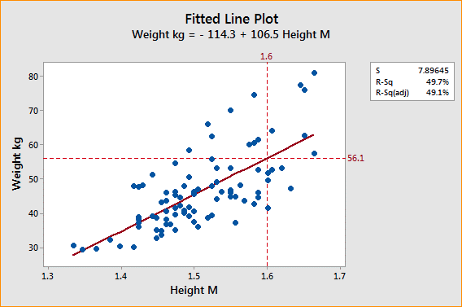

In here identify theta 0 and theta 1 such that it fits training data well. That mean equation fit training data well.

Now if we recognize the theta 0 and theta 1 , and we know the equalion, So if we have X new , theta 0 and theta 1 can **find Y new**

**What happens when you make prediction**

This is our training data (dot) and this is our line we learnt. That mean learnt theta 0 and theta 1.

Get one point (Xi)- acording that found Yi^ (How get put Xi in to equation)

But acctully Y is Yi, Example (X = 2 and Y = 6)

New one --- When you put new value to the equation Yi^ = 4 so error/residual is 2.

In here the error is low mean that prediction or line is good. (Your line fixed the data very well).

**Least Square Method**

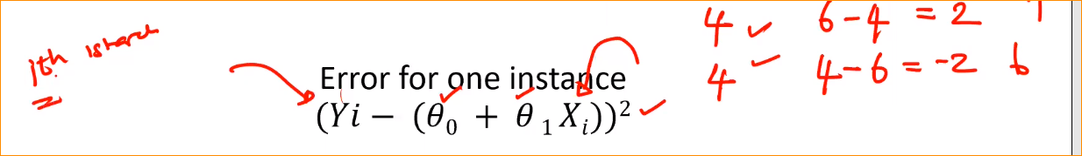

**Objective – minimoize the error fro all the m points in the traning data**

So error for the single instance ? You will have the actual Yi (1 th instance in the traning data.)

Now we know the theta0 and theta 1, Ones we know Xi , So we can put into this equation and get the error.

Why we get Square value ?

1. If you get Yi = 6 and other part 4 that mean value is 2 🡪 Square 4
2. If you get Yi = 4 and other part 6 that mean value is -2 🡪 Square 4

To eliminate (-) value we use Square

This is for single instance.

If we have multiple instances (m points) – we should get sum.

For that calculate the error and get the sum. –

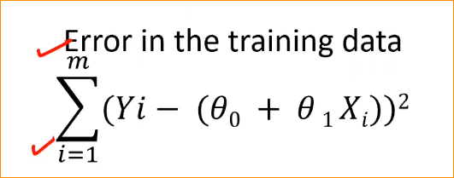

This is all together that error you got using parameters.

We should find theta 0 and theta 1 to minimize the error.

The objective is to minimize the error, all the endpoints of the training data.

This technique called Least Square method-

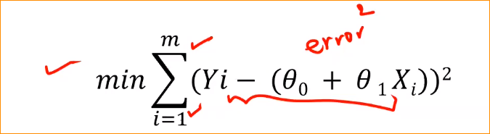

Some time that value is gone really high – like 10+15+25+ …. = 105

So the best practice is the nomalize the number of values(m)

This call **cost funtion**

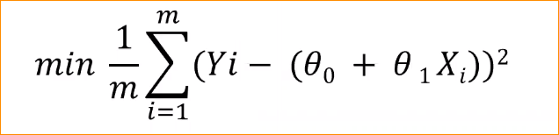

Example

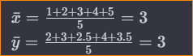

**In simple linear regression – We have to do Is minimize the cost function.**

* In here Xi and Yi 🡪 Labeled training data
* We have a number of Xi and Yi
* Objective is to learn Theta 0 and theta 1 and
* Equation will be minimized

Parameter Estimation –

* Find theta 0 and theta 1 such that 



Taking partial derivative of the cost function, with respect to theta 0 and theta 1

Then equate the 0 to figure out the minimal value.

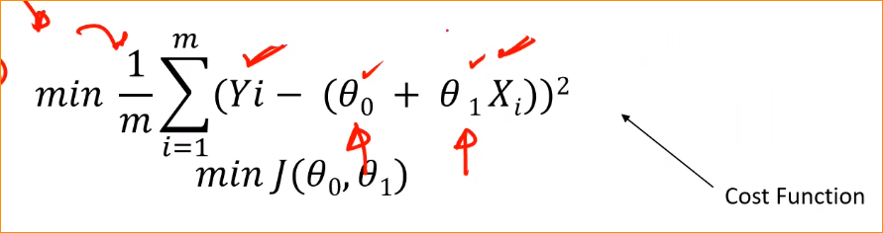

Overall that function like square function, called **convex function.**

Theta 1

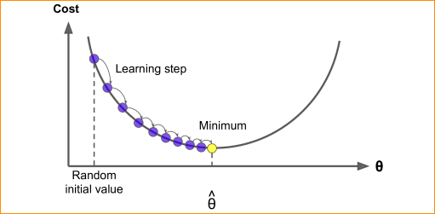

Theta 0

In here Our goal is to find the minimal value.

For that get the partial derivatives = 0

* Get partially derivative respect to theta 0

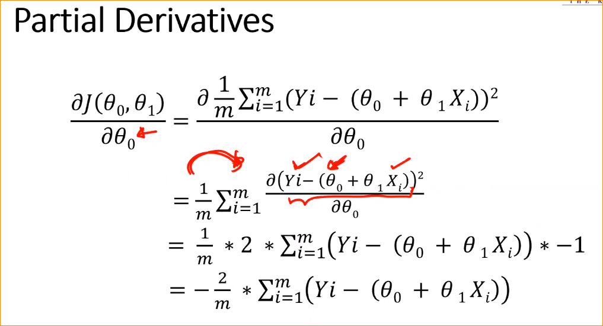

* Get partially derivative respect to theta 1

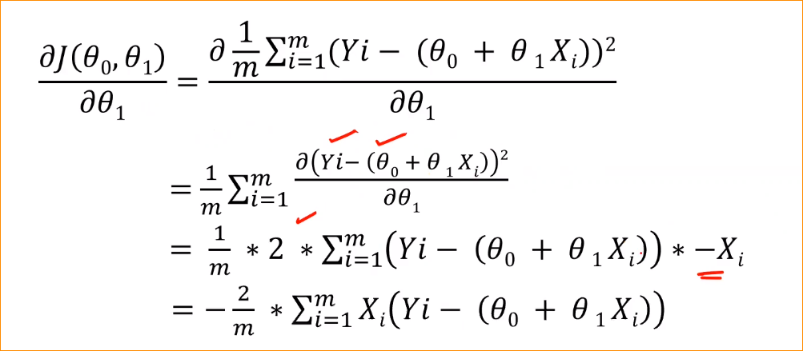

Now we have two equation and equals to 0

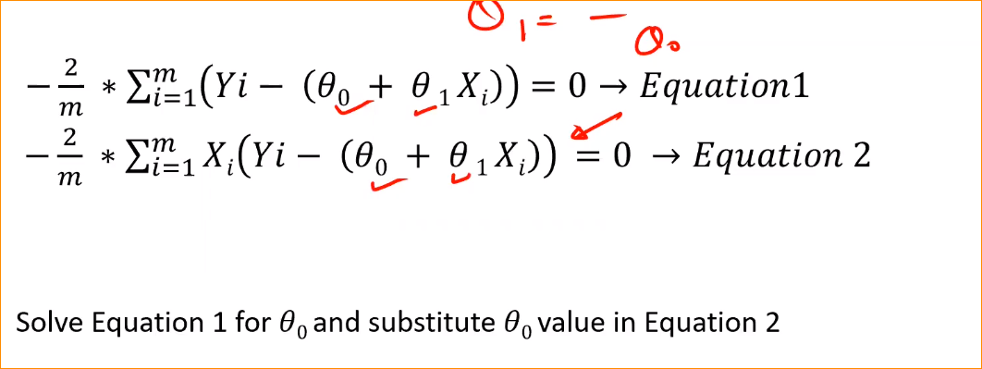

Parameter Estimation –

